Addendum to KIRG Radio Assessment Report dated May XX, 2021

This write up will be amended based on KIRG’s feedback and then added to the official report.

Introduction
In a conference call with members of the KIRG – Brandon Fowler, Keith Endacott and John Ketchum – a request was made for MCP to propose recommendations for a limited budget alternatives, assuming that the available funds may be limited to $500K. At the same meeting, some ideas were discussed, mainly the desire to stop using the Hamaker Control and Odell Butte sites.
MCP recommends two alternative approaches for the limited budget:
- Purchase vehicular repeaters for maximum number of mobile radio users.
- Replace the existing microwave system with a current IP-based equipment and implement a Radio-over-IP system to control stand-alone repeaters at remote sites.
Additionally, MCP recommends KIRG to consider moving all Land Mobile Radio equipment from Odell Butte site to Walker Mountain and shutting down Odell Butte without replacing it. The final decision should be taken based on review of the coverage prediction maps provided by MCP from the point of view of local operational needs.

Option 1: Vehicular repeaters
Based on field observations and computer simulations, mobile coverage in Klamath County is generally satisfactory, especially taking into consideration challenging circumstances – large, mountainous area. Portable coverage, however, is inferior. Widespread use of vehicular repeaters would allow field responders to benefit from that coverage using their portable radios. In addition, some of these vehicular repeaters may be placed in semi-permanent stationary locations, providing temporary coverage improvement on as needed basis.
Based on current market pricing and current KIRG system configuration (vehicular repeaters for digital trunked systems, not recommended by MCP, are typically 505-150% more expensive), the $500k budget would allow purchase of 50-80 such devices, their installation and the necessary associated frequency planning and licensing.
This option solves only one of KIRG users’ challenges, inferior portable coverage, but, since coverage is the most essential performance characteristic of any radio system, this approach is worthy of serious consideration.

Option 2: System upgrade
In the main report MCP identified replacement of obsolete equipment as one of the top priorities for KIRG, with the microwave system being top concern in this category. System congestion was named the most important issue to be addressed overall. KIRG’s desire to cut the annual lease costs for Hamaker Control and Odell Butte sites has also been considered.
All of these concerns can be addressed for under $500K by taking the following steps:
- Replacing the obsolete microwave radios with current production digital, IP model, reusing the existing power and antenna systems
- Adding Radio-over-IP control system/devices to replace the Hamaker Control equipment

MCP’s conservative budgetary calculation indicate that using high-end microwave and networking radios, current microwave can be replaced for approximately $410K (excluding installation costs).
Using high-performance equipment from the second-tier suppliers could yield significant savings, allowing the equipment to be replaced and upgraded by quality equipment including all related services for or even below the same budget. This is based on reusing current power supply and antenna systems, both of which will have to be verified for suitability and checked for performance by a qualified service provider.
One of the side benefits of replacing current microwave with an IP-based system is the ease of interfacing a multitude of inexpensive devices allowing detailed remote monitoring of the remote sites – security and performance. Examples of the parameters recommended for monitoring are included in Section 5.7 of the report.
Implementation of Radio over IP will be enabled by upgrading the microwave system to the IP-enabled platform. RoIP systems and devices can be used to emulate standard remote control methods, such as E&M or tone control using IP backbone. This will enable KIRG to control base stations and other radios as desired from the dispatch positions at any sites where the new microwave can be interfaced. This means exclusion of Bly and Pelican Butte; Bly would remain an independent repeater and Pelican Butte would be controlled by the existing control radios placed at another suitable site, for example Swan Lake.
Please note, the ability to remotely control all remote base stations would have two significant benefits. First it would enable recording of all traffic in the system (except Bly). Second, by giving the dispatcher control over each individual non-simulcast repeater, it would relieve current system capacity concerns because the dispatchers would have the flexibility to patch any repeaters or simulcast channels together to enable wide area operations as needed depending on the nature and location of the incidents and participating agencies.
This option would not affect the existing simulcast system other than:
- Updating the backbone interfaces (a matter of configuration)
- Ability to patch the simulcast system with any other repeater in the network
- Potentially moving Odell Butte site either to Walker Butte or the new site (see below)
The initial budgetary research indicates that the RoIP can be implemented using all existing KIRG radios, even the old Quantar units, for approximately $3K per link. Compatibility of all remote radios and repeaters with remote control schemes should be verified with the current technical support services provider or during potential bidding process.
Accounting for all existing stand-alone repeaters (except Bly but including control radios for Pelican Butte) and HAM backup radios yields 16 radios requiring remote control for the budgetary total of $48K.
Assuming total budget of $500K the above two suggestions would still leave approximately $40K for any associated implementation/planning/licensing services.
The following diagram represents conceptual design of the updated network. The grey box on the left side represents the potential new site replacing Odell Butte. Please note, relocating the Simulcast site from Odell Butte to Walker Mountain would require re-engineering simulcast parameters. This likely can be accomplished by adjusting settings in the system, but some additional steps, such as provision directional antennas, may be required. See the next section for additional related details.

New site discussion
KIRG is considering shutting down the Odell site and provided MCP with data on potential replacement site. MCP performed computer simulations and then compared predicted coverage from Odell Butte, Walker Mountain and the proposed potential new location.
The three following figures describe Mobile-to-Base predicted coverage for the proposed new site, Odell Butte and Walker Mountain. The “New North Site” provides relatively small coverage area, although it fills out the NW corner of the county well. Odell Butte and Walker Mountain provide similar coverage in the entire North area, but Walker Mountain would fill in the central area better than Odell.
The maps used in this document are just a sample of the set of maps provided separately to KIRG.
The ultimate decision needs to be made with participation of the KIRG members familiar with the operational needs of first responders in the north part of the County.
Please note, MCP recommends against use Walker Butte and the new proposed location as simulcast sites; the overlap in coverage between these two locations would make simulcast design extremely difficult if not possible. If both sites are needed for operational needs MCP would recommend operating only one of the sites as a part of simulcast system and the other one as a non-simulcasted repeater.

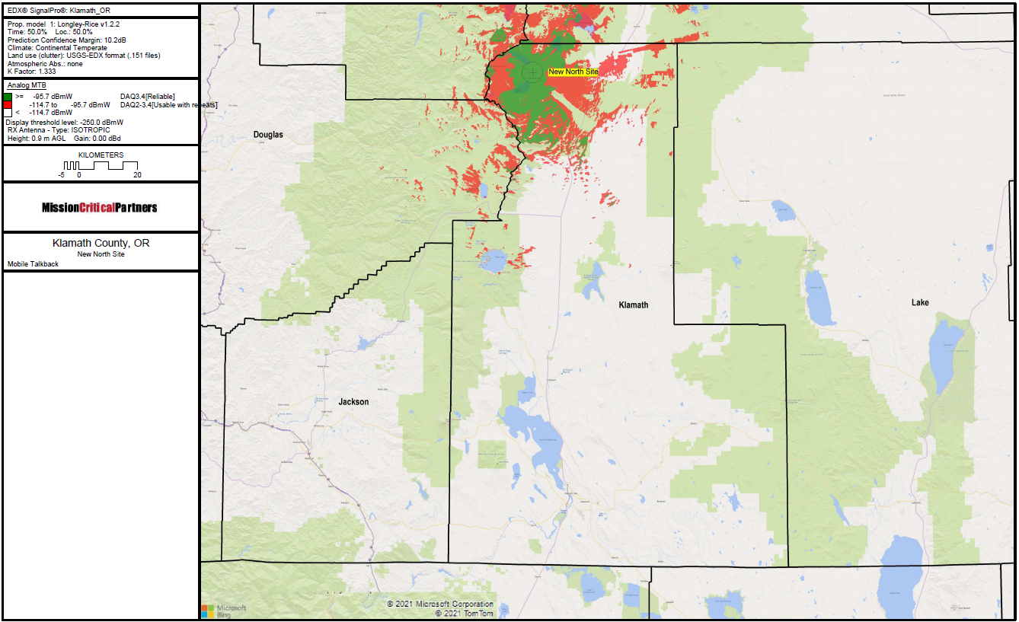
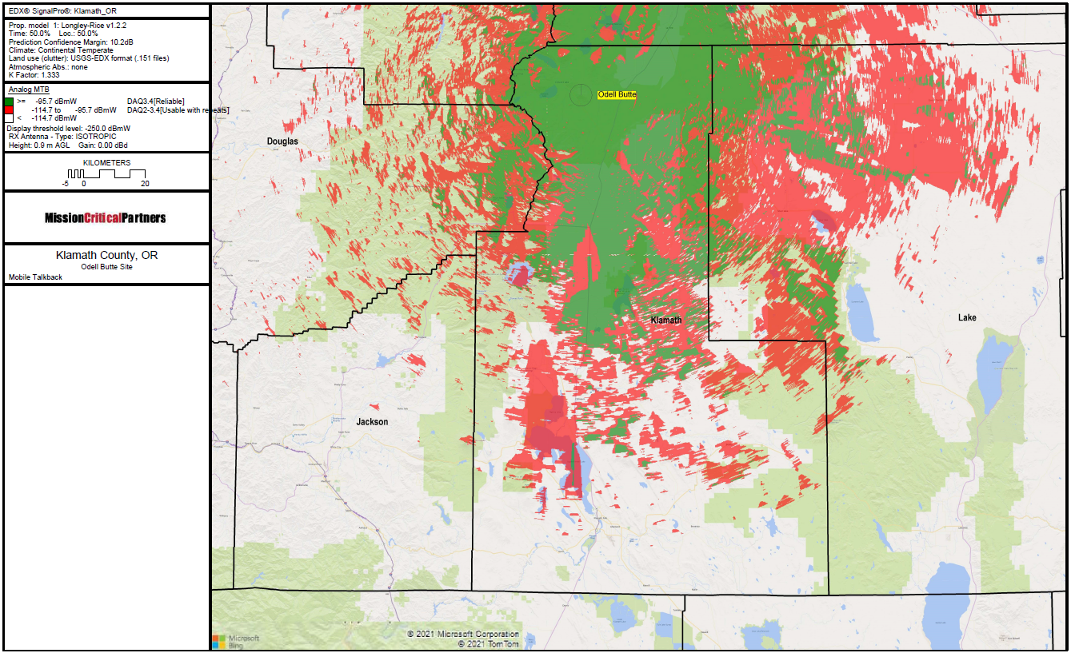
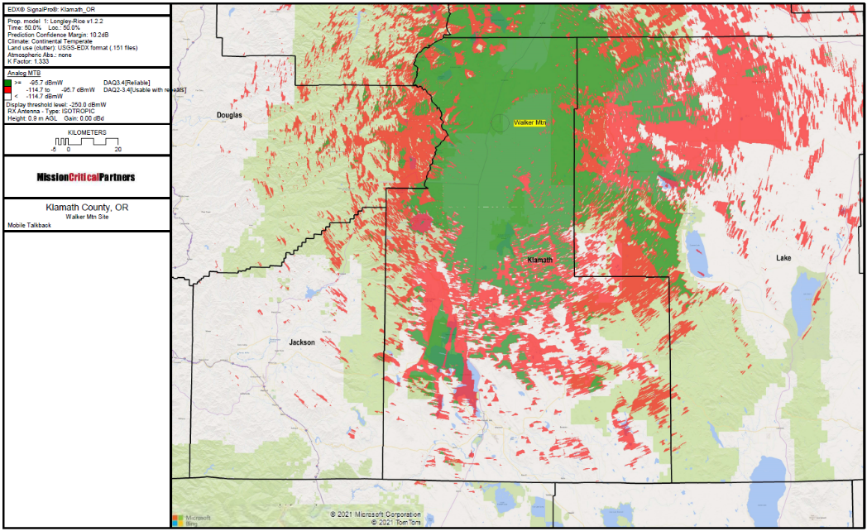

Conclusion
The first suggestion – widespread use of vehicular repeaters – would improve the experience of KIRG’s users in terms of coverage, specifically, allowing use of portable radios wherever mobile coverage is sufficient. It would not address any other concerns identified in MCP’s report.
The second suggestion – updating the microwave system and implementation of RoIP – would not improve coverage performance, but would allow KIRG to drop the Hamaker Control site and address several other concerns identified in MCP’s report:
- Equipment obsolescence (microwave only)
- System congestion
- Radio traffic recording
- Site monitoring
Finally, from a perspective of quantitative analysis of predicted coverage area, Walker Mountain site is superior to Odell Butte and the new proposed site is of limited utility, but MCP recommends that the site selection in this case be based on the actual operational needs rather than arithmetic analysis.

