1. **Project Description**

**What building(s), prehistoric feature, historic feature, or culturally significant feature are you restoring/rehabilitating?**

Nevada State Prison Preservation Society (NSPPS) proposes the restoration of three flights of stairs found in the oldest surviving part of Nevada State Prison: The staircase at the entrance to the administrative building; the tunnel staircase between cell blocks B and C; and the staircase in the northeast corner of the prison yard, leading to cell block A. Once complete, these staircases will be part of the prison’s fire escape route.

**What is the historical significance of the property?**

Nevada State Prison is among the oldest Nevada institutions. Carson City founder Abraham Curry purchased the land for the prison in 1858, building the Warm Springs Hotel there. In 1861, the first Nevada Territorial Legislature met at the hotel, and decided to use the building as a prison, as having a prison helped the territory to meet conditions for statehood. Curry was appointed warden. Inmates quarried sandstone for the new state Capitol. A proper prison would later be built and expanded with quarry stone as well.

In 1871, 29 inmates escaped the prison, killing guard Jeff Isaacs, wounding three others, and killing bystander Matt Pixley in the process. Law enforcement pursued them south, until 18 remaining escapees made a stand at what is now known as Convict Lake. All were killed in the following shootout, or captured and lynched soon after. As a result, Lieutenant Governor Frank Denver was removed as warden in 1873. He refused to vacate his position until Governor Lewis Bradley mobilized the state militia against the prison.

Over the years, prison labor became the source of further sandstone from which many of Nevada’s historic buildings were constructed, making the prison a part of every facet of state history. Alongside the Capitol, prison stone was used in the governor’s mansion, attorney general’s office, Bank Saloon and many others. Even some wooden structures, such as St. Peter’s Episcopal Church, Carson City, are built on foundations made of prison stone. Some of these structures were designed by Frederic DeLongchamps.

In the quarrying process, inmates eventually discovered fossilized sloth footprints and even mammoth remains in the sandstone, connecting the prison to Nevada’s prehistory as well. Thus, by 1882, the still-active prison had become a tourist attraction. According to a report made for the Nevada State Prison Steering Committee, the site remains “suitable for scientific research.”

By 1905, the prison was made the site of all state executions. In total, the prison was the site of 51 executions, many of which have demonstrated the shifting nature of capital punishment over the decades. The first execution by gas in the United States, that of Gee Jon, took place at the prison in 1924. In 1985, serial killer Carroll Cole, who had 16 known victims, was the first in the state to die by lethal injection.

The prison has also been the setting of numerous movies, including *Flesh and Blood* (1979), one of Denzel Washington’s first appearances on screen, and *An Innocent Man* (1989), starring Tom Selleck. After the prison closed in 2012, *The Mustang*, produced by Robert Redford, was filmed at the prison with the help of local talent in 2017. Two years later, it premiered at Sundance Film Festival to extremely positive reviews.

**How do you propose to restore/rehabilitate it?**

NSPPS is in a multi-year program of repairing the oldest part of the complex: The administrative building and cell blocks which enclose the prison yard. In their earliest form, they were completed in 1925, likely re-using stone which had been cut for earlier buildings on the site. Work has already been accomplished, and more is underway.

As part of this program, NSPPS will repair three heavily-eroded stairways by demolishing and replacing unstable concrete stairs, and repointing the masonry underneath them with Jahn mortar from Cathedral Stone Products, the same product currently being used to repair the Capitol. This will restore each stairway to exactly its original appearance, and serve as the pathway for the prison’s fire escape plan.

**Who will be doing the work?**

The work will be conducted by Newcastle Masonry in Reno and Newt Concrete of Carson City, under the direction of Lee Perks of Perks Petroleum.

**What is the timeline for the project?**

The timeline for the project is March to June of 2025.

**Who holds title to the property?**

The title for Nevada State Prison is still held by the Department of Corrections.

1. **Building use/community involvement**

**How and by whom will the facility be used?**

The prison currently serves as a museum for the public. Tours for locals and tourists are conducted by volunteers, including former prison staff. Volunteer yard crews engage in maintenance. In addition, the building already hosts a large and growing variety of local cultural events, such as fundraisers, galas, historical lectures, art galleries and concerts. Recently, the prison has been the site of a fundraiser for Friends in Service Helping (FISH), a nonprofit that provides housing and job training to those in need.

In addition, “paranormal investigators,” or ghost-hunters, believe the prison to be haunted, and offer nighttime tours of their own. The prison was featured on Travel Channel’s *Destination Fear* in 2021. A paranormal tour was one of the attractions at the FISH’s event on April 18, 2024. Further, the Department of Public Safety uses the prison for active shooter training (free of charge), and the National Guard has used the prison for hazmat training.

As noted above, *The Mustang* was filmed at the prison recently. NSPPS is open to further film projects. The restoration of historic features would be a boon for this purpose. By comparison, the State of Georgia has used its unique features to bring in money from financial successes such as *The Walking Dead*, *The Hunger Games* and *Stranger Things* – all of which were filmed partly at Bellwood Quarry, outside of Atlanta. A similar approach could bring untold numbers of tourists and job opportunities to Carson City.

**Who will be responsible for the management of the building and its programs/activities?**

The NSPPS will be responsible for the management of the building and its programs.

**How has the community continued to be involved in your project**?

The NSPPS Board of Directors, tour guides and yard crews are composed of locals. Local volunteers have donated many hours to the cleanup of the building, and local tradesmen have contributed to its repair.

**How will the community continue to be involved in your project?**

The project of repairing the three stairways will be managed by local contractor and NSPPS board member Lee Perks. The work itself will be completed by local tradesmen.

**How will the community continue to be involved in the use of the building?**

Prison events have been held on the behalf of local nonprofits, artists, historians, law enforcement agencies and businesses. Cultural events of increasing variety will continue to be hosted at the prison, many of which already provide repeat business.

**How are your restoration plans related to the uses of the building?**

Parts of the prison cannot be conveniently accessed without the repair of the three staircases. The more the building is rendered useful, the more and larger the events that can be hosted. Specifically, the restoration of the three staircases will simplify access and egress throughout the complex, and serve as the prison’s fire escape route.

**What importance to tourism will the facility have?**

The prison is already visited on a regular basis by both tourists and locals with an interest in history. Prison tours are often the centerpiece of local historical tourism. Alcatraz Prison, for example, brings in $60 million of revenue per year. When all parts of Nevada State Prison are fully operational, as a museum and a location for community events, the local economic benefit can only increase. A historical tour that included the prison could make a visit to Carson City a three-day affair, with all that would entail for local hotels, restaurants and other businesses. If more television and movie filming were done at the prison, such a tour could bring in even more money.

The prison is also a longtime favorite of paranormal investigators who consider it to be haunted. A single YouTube video of the prison, posted by OmarGoshTV, has been viewed one million times in a year. For lack of a better word, the prison has “clout.” With more and better access to the building, that clout would naturally increase, as would Carson City’s economic leverage.

1. **Project support/ Financial**

**What specific contributions (cash, land, labor, materials, etc.) have been provided toward the project from the community and/or other sources?**

Other contributions or matching are not expected for the staircase project.

**What grants and additional funding (last three years), including amounts, has the organization received or will receive for this project?**

No grant money has been secured in the last three years for the repair of the staircases.

**What additional contributions are projected to complete the project?**

Additional contributions are not currently expected.

**How will your facility sustain itself financially in the future? Please provide evidence that you can implement the project and maintain a viable program in the future.**

Income from memberships, tours, the gift shop, private donations and an increasing number of events, have sustained the prison, and will continue to do so. In that time, both paid and volunteer labor have improved the fabric of the building itself. NSPPS is also revisiting grants as a source of revenue.

1. **Planning**

**If your project includes planning, please describe the process.**

The need to repair the staircases is straightforward. As such, all that was necessary was to find a mason who was capable of executing the project, and invite him on a walkthrough of the prison so that he could assess damage and offer a quote.

**Who will participate in the planning?**

The project will be planned by Lee Perks, Membership Co-Chair. He has worked in construction since 1974, and has already contributed to the restoration of the prison.

**Who will coordinate it?**

Planning is being coordinated by the same Lee Perks, board member and contractor.

**How will the community be involved? Please note that projects requesting funds for planning may be supported only if the planning is part of a construction project.**

The tradesmen and the project manager will be the only ones with significant involvement in this project, which is of a technical nature, and not a good candidate for further community involvement, such as volunteer work.

**If your project is based on previous planning, please describe. Be sure to include all relevant studies and planning documents in the following supplemental materials section of the application, even if previously provided in a prior grant cycle.**

Attempts to forestall the prison’s closing resulted in the publication of a *Facility Condition Analysis* in 2009. In addition, the *Historic Structure Report,* produced for the Carson City Planning Department in 2016, contains directions suited to restoring the prison as a museum. NSPPS consults both sources.

**1. A paragraph (200 words maximum) describing the current or intended future use of the**

**Property and cultural center programming.**

Currently, Nevada State Prison is used for a wide variety of community events, and this is its

intended future as well. The prison is, first and foremost, a museum of state and prison history,

open to the public almost year-round, except when winter ice and snow make the concrete

walkways unusable. The prison also hosts paranormal tours, community events, fundraisers,

galas, art galleries, concerts and law enforcement and military trainings, and has participated in

the filming of movies. The Nevada State Prison Society (NSPPS) expects the prison to continue

to host events of this kind in perpetuity. Further events are currently being planned.

**2. A printout from the County Assessors website that shows the current owner of the**

**property with the APN number clearly displayed; and**

The printout is contained in the appendix.

**3. Photographs of all exterior elevations with views, identified* and keyed to a site plan;**

**and**

1. **Admin Stairs**

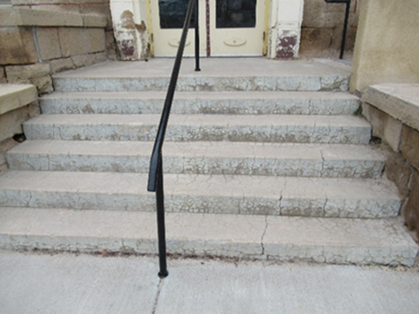

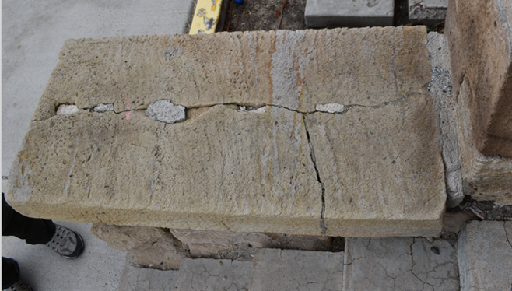

1. **Cell block stairs**

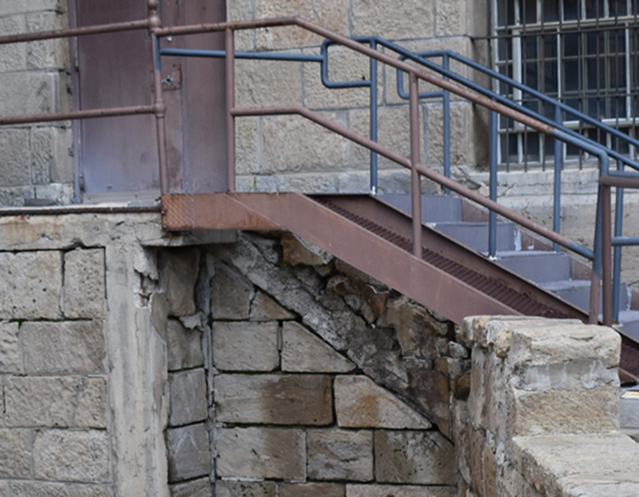

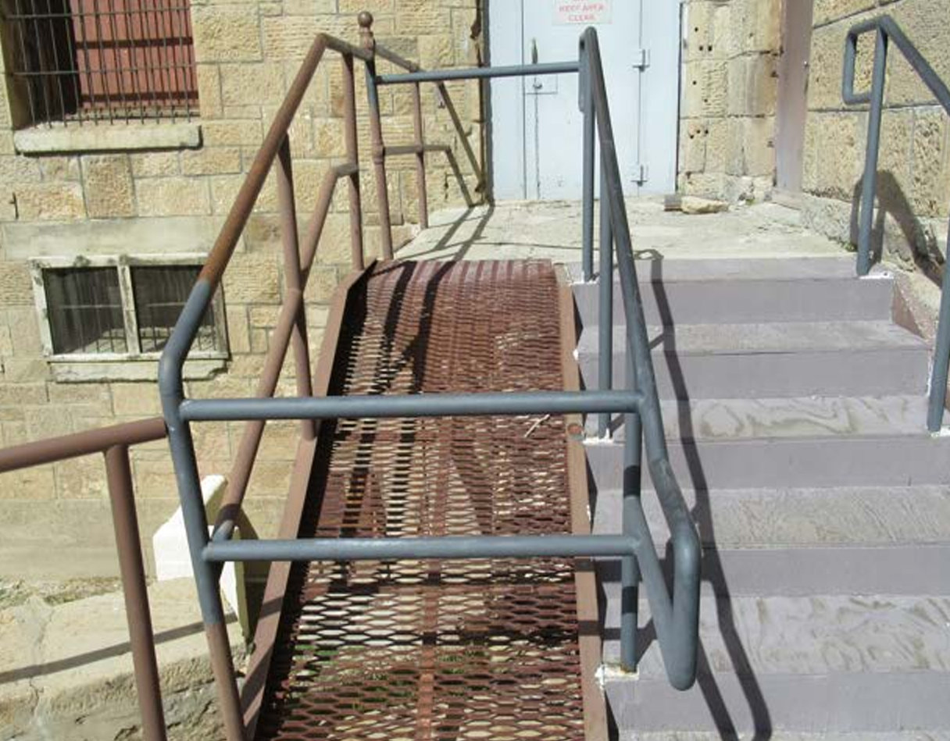

1. **Tunnel Stairs**

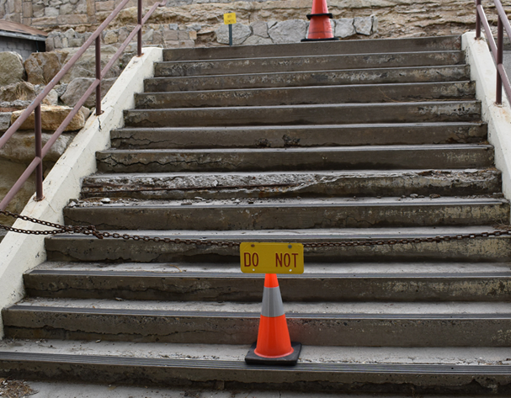

**Site Plan:**

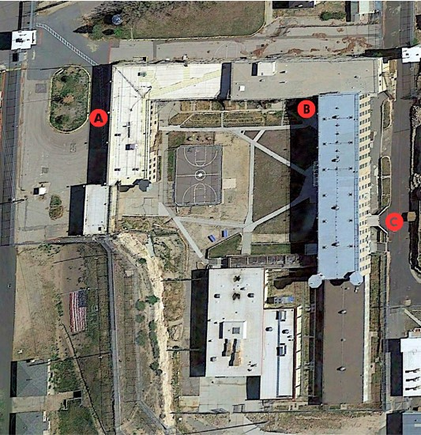

**4. Photographs of all major rooms and project rooms, labeled and keyed to a floor plan;**

**and**

All of the stairways that NSPPS proposes to repair are outside, so there are no inside

photographs to present.

**5. Organization’s articles of incorporation, mission statement, length of time established,**

**and history; and**

**Articles of incorporation:** See appendix.

**Mission:** The mission of NSSPS is the preservation of the Nevada State Prison for the education of the State's citizens and visitors, regarding the role of the institution in the development of Nevada's government, the architecture of Carson City and the protection of Nevada communities.

**Length of time Established**: NSPPS was created by the state legislature in 2012, and has existed for 12 years.

**History:** NSPPS was founded by the state legislature in 2012 but incorporated as a federal nonprofit in April 2014. It held its first major event, a celebration of the 70th anniversary of the Carson City Chamber of Commerce, which had 500 attendees, in June 2015. NSPPS placed the prison on the National Register of Historic Properties in October of that year, and the publication of a Historical Structure Report in 2016 gave NSPPS a blueprint for repairs to the building, which have taken place on a continuous basis.

The main attraction at the prison has long been both its historic and paranormal tours, which have run more-or-less concurrently since at least 2016. Since that time, an increasing number of tours, galas, fundraisers and other events have contributed further funding and media attention and funded an increasing round of repairs. While COVID-19 social distancing procedures slowed progress in recent years, the passage of Assembly Bill 525 in 2023 set aside $1 million for the repair of the prison roof. That repair is currently ongoing.

**6. A list of current board members for the organization; and**

Maurice White                 President

Glen Whorton                  Vice President

Didi Chaney                     Secretary

Lynne Knack                    Treasurer

Terry Hubert                     Maintenance

Susan Bernard                Paranormal

LeRoy Perks                  Planning

Brian Hutchins             Legal Counsel

Chris Pitzer Social Media

**7. A copy of the organization’s long-range plan including information on how frequently**

**the plan is updated; and**

The long-term goals of NSPPS are found in Article 2 section 2 of the NSPPS Bylaws: “The specific objectives and purposes of this corporation shall be: to preserve and maintain the

decommissioned Nevada State Prison for the education of the present and future generations as

to the history and use of the prison.”

To accomplish these goals, NSPPS will generally follow the Recommendations, beginning on page 6, found in the report named *Future of the Nevada State Prison*, presented to the 2015 Nevada State Legislature. Additionally the NSPPS will foster private and public collaborations that result in:

1. Commercial and philanthropic endeavors that present to the public the anthropogenic and natural history of the NSP.

2. The protection, preservation, restoration, and conservation of the various facilities and natural paleontological resources within the historical grounds of the NSP.

**8. A list of the organization’s activities for the past fiscal year or calendar year, (if**

**applicable); and**

In the past calendar year, NSPPS has conducted:

* Monthly Board of Director meetings, monthly publication of the newsletter *Cellhouse Snitch,* and regular groundskeeping by volunteers;
* Historical and paranormal tours of the prison grounds;
* Hosted a variety of community events;
* Trainings for prison tour guides;
* Law enforcement trainings conducted by the Department of Public Safety, and open to other agencies, provided free of charge;
* Fine-tuning of museum exhibits housed in the administrative building, including the expansion of a collection of shanks and other (sometimes rare) prison-related antiques;
* Staging of the warden’s office, which restored it to its original appearance.

**9. A detailed report on current CCCHP grant status (if applicable), as well as the outcome of previous CCCHP or CCA grants (if applicable); and**

NSPPS has received a grant from SHPO in FY2019-2020 for the replacement of flooring and repair of the roof, in the total amount of $25,900. Both repairs are complete.

**10. A current list (last three years) of all grants (regardless of source) and additional**

**funding, including amounts the organization has or will receive (if applicable).**

While the prison has not received grants in the last three years, and is not yet applying for others,

it did receive one million dollars from the State for roof repairs. Further financial information

may be found in the appendix.

Appendix

To avoid a bulky proposal, three planning documents – *Facility Condition Analysis*

(2009), *Future of the Nevada State Prison* (2015) and *Historic Structure Report*

(2016) – have been uploaded to SHPO’s FPT site under the heading “Christopher

Cox – Nevada State Prison Application Large Size Documents.”